SIMATS ENGINEERING

ASSESSMENT TOOL 2
COURSE NAME: Cryptography and Network Security
COURSE CODE: CSA5116
COURSE OUTCOME COVERED
CO1: Apply classical encryption techniques using symmetric and asymmetric ciphers to encrypt and decrypt data for the ensuring data security. (BL3, BL4)
Assessment Tool Weightage: 20%
QUESTIONS: 5 Total Marks:50
Annexure A

CONCEPT MAPPING
Code of Conduct:
I ____________VARSHA.S/192511358________ (Name / Reg No) certify that this submission is my original work and that I have adhered to the guidelines specified for this assessment.
I understand that any violation of academic integrity rules will result in disciplinary action.
Signature of the student:


Annexure A

CONCEPT MAPPING
- Create a concept map linking the following: Security Attacks, Threats, Risks and Security Goals (Confidentiality, Integrity, Availability. Perform the following tasks:
  - Show how each attack leads to specific threats and risks
  - Map how security goals help mitigate them Provide one real-world example for each link
- Develop a concept map comparing substitution techniques: Caesar Cipher, Monoalphabetic Cipher, Vigenère Cipher and Hill Cipher. Perform the following tasks to connect based on: Key usage, Complexity and Security strength. Analyze which technique is most secure and why.
- Construct a concept map for Classical Encryption Schemes: Substitution Techniques and Transposition Techniques. Perform the following tasks:
a. Show differences and similarities
i.Map how each affects the Data structure and Security level ii.Analyze which is more vulnerable to attacks and why
- Create a concept map connecting Steganography concepts: Data Hiding, Watermarking and Survivability. Perform the following tasks:
  - Show relationships between these concepts
  - Analyze how each contributes to secure communication
  - Include one real-world application for each
- Draw a concept map linking number theory concepts used in cryptography: Modular Inverse, Extended Euclid Algorithm, Fermat’s Little Theorem, Euler’s Phi Function and Euler’s Theorem. Perform the following tasks:
  - Show how each concept is mathematically connected
  - Map their role in encryption/decryption
  - Analyze which concept is most critical for public key cryptography and justify

Criteria | Weighta ge | Level 4 –  Exemplary | Level 3 –  Proficient | Level 2 –  Developing | Level 1 –  Beginning
RUBRICS FOR CALCULATION:

Understandi ng of  Concepts | 25 | Demonstrates thorough understanding and effectively integrates multiple concepts/technolo gies | Good understandi ng with proper integration of most concepts | Basic understandin g; limited or partial integration | Poor understandin g; unable to integrate concepts
Experiment al Design | 30 | Well-planned, systematic implementation with optimal solution | Correct implementat ion with minor issues | Basic implementati on with errors or inefficiencies | Incorrect or incomplete implementati on
Use of Tools | 20 | Effective and advanced use of tools/technologies with proper configuration | Appropriate use of tools with correct execution | Limited or inconsistent use of tools | Incorrect or minimal use of tools
Analysis of Results | 15 | Insightful analysis with accurate interpretation and validation of results | Good  analysis with reasonable interpretatio  n | Basic analysis with limited insights | Poor or incorrect analysis of results
Documentat  ion | 10 | Clear, wellstructured documentation with diagrams, code, and results | Organized documentati on with necessary details | Basic documentatio n with missing details | Poor or incomplete documentatio n

Question 1

Concept Map: Security Attacks, Threats, Risks and Security Goals

Concept Map
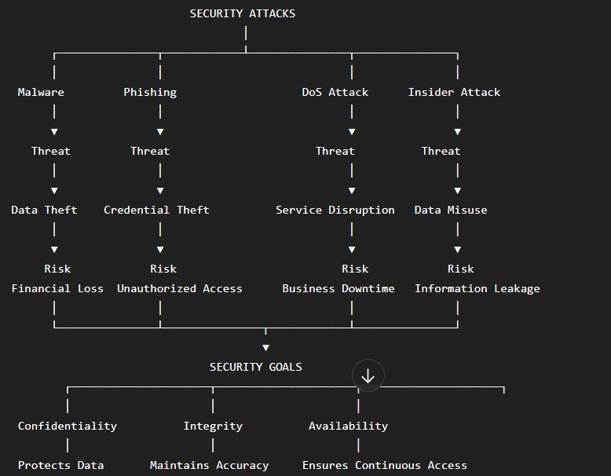

a. How Each Attack Leads to Threats and Risks
Security Attack | Threat Created | Risk Involved
Malware | Data corruption and theft | Financial loss and system damage
Phishing | Credential theft | Unauthorized account access
DoS Attack | Service interruption | Business downtime
Insider Attack | Misuse of confidential information | Information leakage

b. How Security Goals Mitigate Them
Security Goal | Mitigation
Confidentiality | Prevents unauthorized access using encryption and authentication.
Integrity | Prevents unauthorized modification using hashing and digital signatures.
Availability | Ensures systems remain accessible using backups and redundancy.

Real-World Examples
Attack → Threat → Risk → Security Goal | Example
Malware → Data Theft → Financial Loss → Confidentiality | A ransomware attack encrypts company files. Encryption and access control help protect sensitive data.
Phishing → Credential Theft → Unauthorized Access → Confidentiality | An employee clicks a fake banking email and loses login credentials. Multi-factor authentication prevents unauthorized access.
DoS Attack → Service Disruption → Business Downtime → Availability | An online shopping website becomes unavailable during a cyberattack. Load balancing and backup servers maintain service availability.
Insider Attack → Information Leakage → Data Breach → Integrity | An employee modifies customer records. Audit logs and access controls maintain data integrity.

Conclusion
Security attacks generate threats that create risks for organizations. The three primary security goals—Confidentiality, Integrity, and Availability (CIA Triad)—help reduce these risks by protecting data, ensuring accuracy, and maintaining continuous system access.

Question 2

Concept Map: Comparison of Substitution Techniques

Concept Map

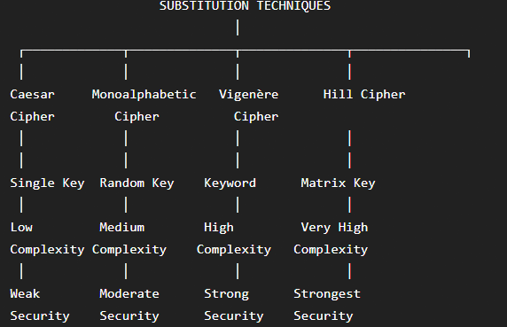

omparison Table
Technique | Key Usage | Complexity | Security Strength
Caesar Cipher | Single shift key | Very Low | Very Weak
Monoalphabetic Cipher | Random substitution alphabet | Medium | Moderate
Vigenère Cipher | Keyword | High | Strong
Hill Cipher | Matrix key | Very High | Very Strong

Analysis

Caesar Cipher
- Uses one fixed shift.
- Easy to break using brute force.
- Lowest security.

Monoalphabetic Cipher
- Uses a randomly generated substitution alphabet.
- Stronger than Caesar Cipher.
- Vulnerable to frequency analysis.

Vigenère Cipher
- Uses multiple substitution alphabets.
- Harder to break than previous methods.
- Provides stronger security.

Hill Cipher
- Uses matrix multiplication.
- Encrypts multiple letters simultaneously.
- Offers the highest level of security among classical substitution techniques.

Most Secure Technique

Hill Cipher
Reasons:
- Uses matrix-based mathematical encryption.
- Encrypts blocks of letters instead of single characters.
- More resistant to frequency analysis.
- Requires linear algebra knowledge to decrypt.

Conclusion
Among the four techniques, the Hill Cipher provides the strongest security due to its mathematical approach and block encryption. The Caesar Cipher is the weakest because of its limited key space and simple shifting technique.

Question 3

Concept Map: Classical Encryption Schemes

Concept Map
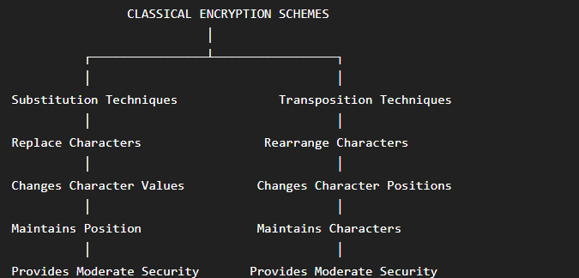

a. Differences and Similarities

Similarities
- Both are classical encryption methods.
- Both convert plaintext into ciphertext.
- Both require a secret key.
- Both aim to protect confidential information.

Differences
Substitution Techniques | Transposition Techniques
Characters are replaced. | Characters remain the same but are rearranged.
Character values change. | Character positions change.
Frequency distribution remains similar. | Letter frequency remains unchanged.
Example: Caesar Cipher | Example: Rail Fence Cipher

i. Effect on Data Structure and Security Level
Feature | Substitution | Transposition
Data Structure | Character values change | Character positions change
Readability | Completely altered | Rearranged text
Security Level | Moderate | Moderate
Encryption Method | Letter replacement | Letter rearrangement

ii. Vulnerability Analysis
Technique | Vulnerability | Reason
Substitution | Frequency Analysis | Letter frequencies remain predictable.
Transposition | Pattern Analysis | Character frequencies remain unchanged, making rearrangement easier to detect.

Which is More Vulnerable?

Substitution Techniques
Reasons:
- Repeated letters remain repeated after substitution.
- Frequency analysis can reveal the plaintext.
- Simpler substitution methods (such as Caesar Cipher) have very small key spaces.
Although both techniques have weaknesses, simple substitution ciphers are generally more vulnerable because attackers can use frequency analysis to recover the original message.

Conclusion
Classical encryption schemes include Substitution and Transposition techniques. Substitution changes the characters, while transposition changes only their positions. Both improve data confidentiality but are vulnerable to cryptanalysis. Combining both techniques provides stronger security than using either method alone.
QUESTION 4: CONCEPT MAP – STEGANOGRAPHY CONCEPTS
Concept Map
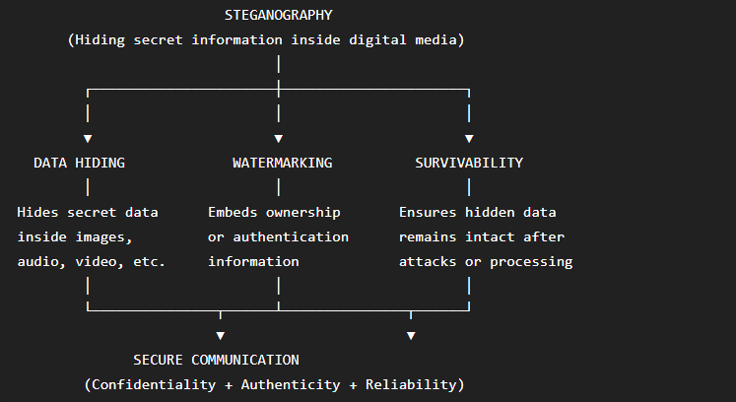

a. Relationship Between the Concepts
Concept | Relationship
Data Hiding | Conceals confidential information inside digital media without revealing its existence.
Watermarking | Embeds ownership or authentication information into digital media to prove originality and prevent unauthorized use.
Survivability | Ensures that the hidden data or watermark remains intact even after compression, resizing, editing, or transmission.
Relationship Summary
- Data Hiding provides confidentiality.
- Watermarking provides authentication and ownership verification.
- Survivability provides robustness and reliability.
- Together, all three techniques improve secure communication.

b. Contribution to Secure Communication
Concept | Contribution
Data Hiding | Keeps confidential messages invisible to unauthorized users.
Watermarking | Protects digital content from piracy and verifies authenticity.
Survivability | Ensures hidden information remains recoverable after image processing or attacks.

c. Real-World Applications
Concept | Real-World Application | Example
Data Hiding | Secret Communication | Intelligence agencies hide confidential messages inside digital images.
Watermarking | Copyright Protection | Photographers embed invisible watermarks in digital photographs to prevent piracy.
Survivability | Secure Multimedia Transmission | Medical images retain hidden patient information even after compression or resizing.

Analysis
- Data Hiding protects the secrecy of information.
- Watermarking protects ownership and authenticity.
- Survivability ensures the hidden information is not destroyed during transmission or modification.
- Together, these techniques provide confidentiality, integrity, authentication, and robustness, making communication more secure.

Conclusion
Steganography combines Data Hiding, Watermarking, and Survivability to ensure that information remains hidden, authentic, and protected. These concepts are widely used in military communication, copyright protection, medical imaging, and secure digital communication.
QUESTION 5: CONCEPT MAP – NUMBER THEORY CONCEPTS USED IN CRYPTOGRAPHY
Concept Map
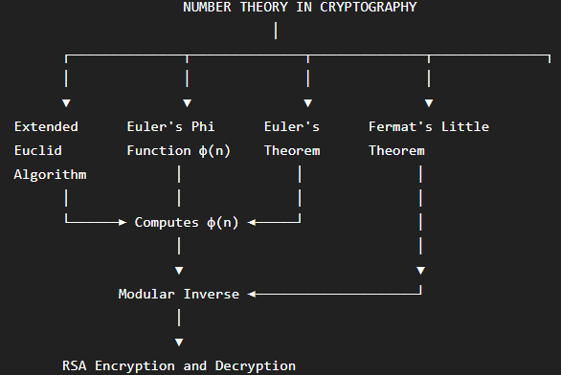

a. Mathematical Connection
Concept | Mathematical Connection
Extended Euclid Algorithm | Computes the Greatest Common Divisor (GCD) and is used to find the Modular Inverse.
Modular Inverse | Finds the multiplicative inverse of a number modulo n.
Euler's Phi Function φ(n) | Counts the number of integers that are relatively prime to n.
Euler's Theorem | States that if gcd(a, n) = 1, then a^φ(n) ≡ 1 (mod n).
Fermat's Little Theorem | Special case of Euler's Theorem when n is a prime number: a^(p−1) ≡ 1 (mod p).

b. Role in Encryption and Decryption
Concept | Role in Cryptography
Extended Euclid Algorithm | Computes the modular inverse required to generate the RSA private key.
Modular Inverse | Used to calculate the private decryption key.
Euler's Phi Function | Used in RSA key generation.
Euler's Theorem | Forms the mathematical basis for RSA encryption and decryption.
Fermat's Little Theorem | Simplifies modular arithmetic and is used in cryptographic algorithms involving prime numbers.

c. Most Critical Concept for Public Key Cryptography

Most Critical Concept: Modular Inverse

Justification
- RSA requires the private key d, which is calculated using the modular inverse:
$$d≡e^{-1}(modϕ(n))$$
- The Extended Euclid Algorithm is used to compute this modular inverse efficiently.
- Without the modular inverse, the private key cannot be generated.
- Since decryption depends on the private key, RSA cannot function without the modular inverse.

Summary Table
Concept | Importance
Extended Euclid Algorithm | Computes Modular Inverse
Modular Inverse | Generates RSA Private Key
Euler's Phi Function | Used in RSA Key Generation
Euler's Theorem | Mathematical foundation of RSA
Fermat's Little Theorem | Simplifies modular exponentiation with prime numbers

Conclusion
Number theory forms the foundation of modern public-key cryptography. Euler's Phi Function, Euler's Theorem, Fermat's Little Theorem, Modular Inverse, and the Extended Euclid Algorithm work together to enable secure encryption and decryption. Among these, the Modular Inverse is the most critical because it is essential for generating the RSA private key, making secure communication possible.

